Studio 8

Name and Student Id: Xin Xu 30421225

Self-Evaluation:

|  |  |  |  |  |  |
| --- | --- | --- | --- | --- | --- |
| Need Help | Work in Progress | Pass | Credit | Distinction | ***High Distinction*** |

Tutor Evaluation:

|  |  |  |  |  |  |
| --- | --- | --- | --- | --- | --- |
| Incomplete | Needs improvement | Pass | Credit | Distinction | High Distinction |

Task 8.1:

{Answers}

I have done this

{Screenshots}

A screenshot of sending email

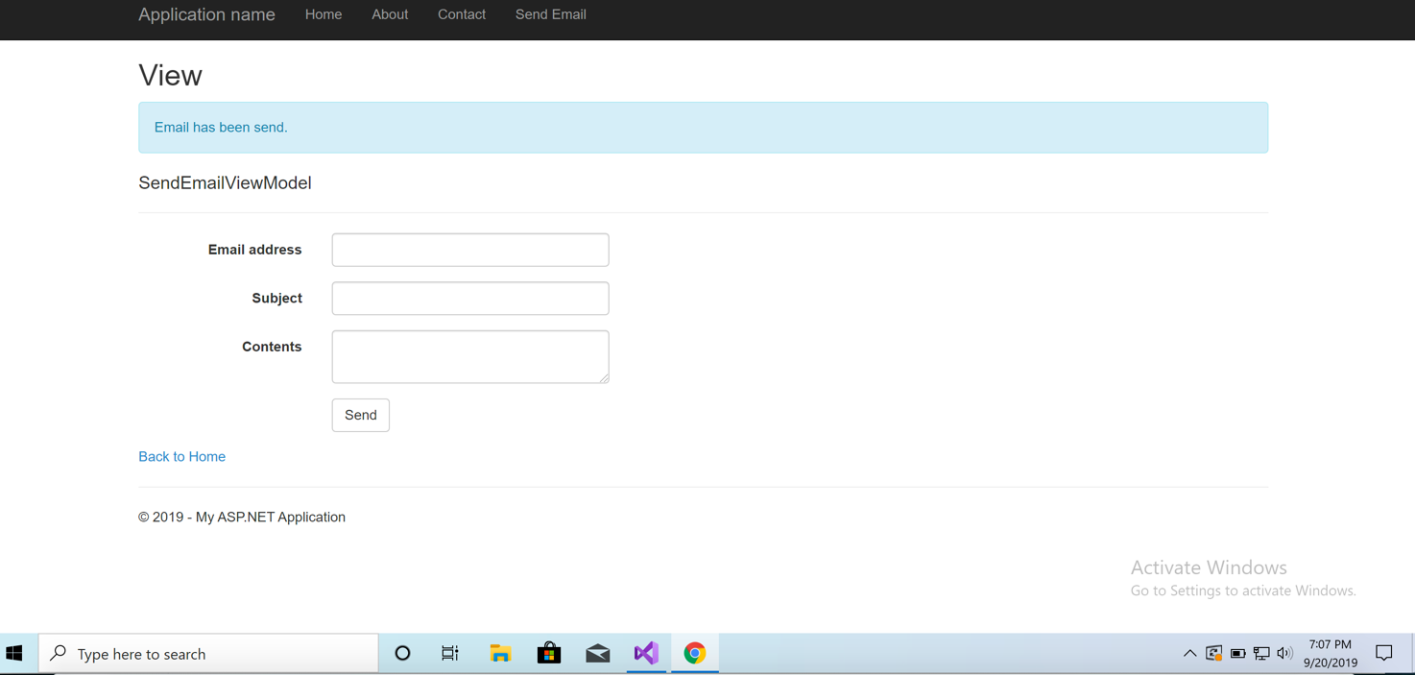

A screenshot of receiving email

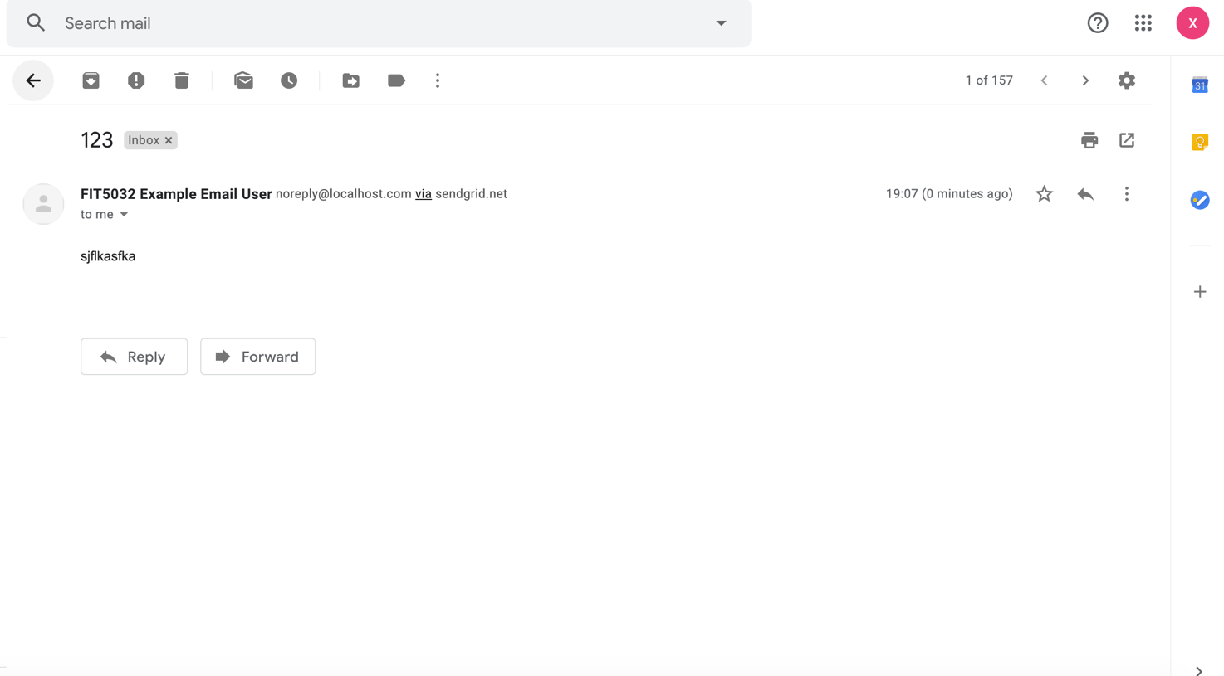

A screenshot of SendGrid console

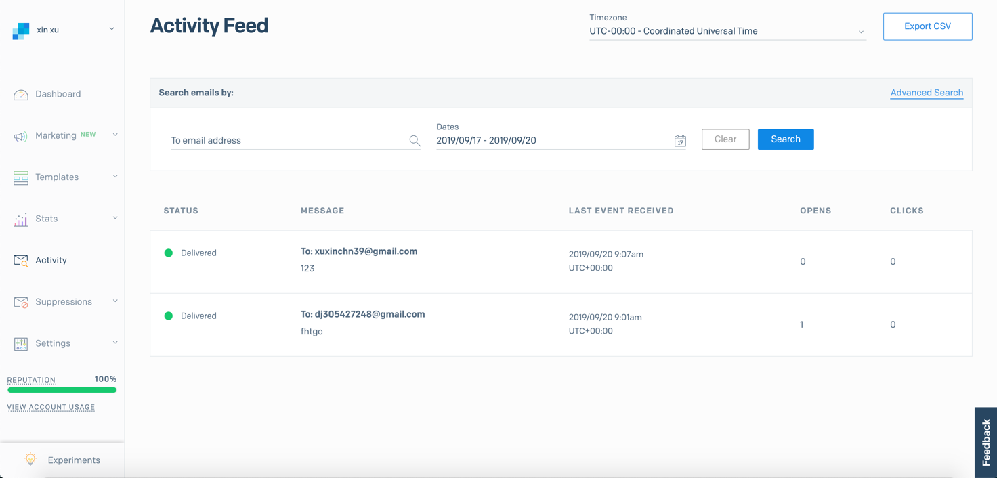

{Link to code repository}

{References}

{URLs}

https://drive.google.com/drive/u/1/folders/1EJm0eM0xhxAZXouHovffv0YsfZgxz1be

Task 8.2:

{Answers}

Advantages:

1. provide bulk email function because the third-party servers like SendGrid are configured to allow massive numbers of emails to be sent in short periods of time.

2. could not be marked as SPAM because they have relationships with ISPs and are approved as bulk mail delivery services

3. Third-party systems protect your website and work to maintain the highest possible delivery rates.

4. These systems also offer some extra extensions such as robust reporting and analysis tools.

Disadvantage:

1. the quality of the hosting service will depend on the provider.

2. response times can be slower in the midnight or on a weekend

3. critical business data stored by a third-party provider which will lead to the Security problems

{Screenshots}

{Link to code repository}

{References}

https://savoirfaire-us.com/blog/the-advantages-of-third-party-email-service-providers/

https://www.allbusiness.com/e-mail-hosting-in-house-servers-vs-third-party-providers-4092892-1.html

{URLs}